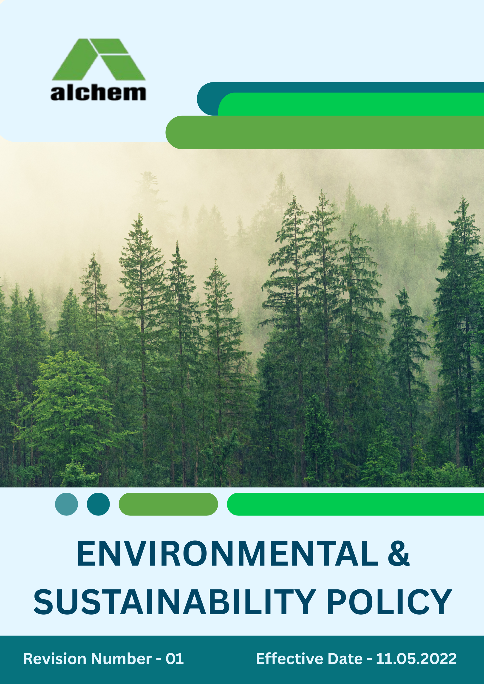
Index

❖ Introduction: 3
❖ Environment Commitment: 3
❖ Quantifying our Commitments to Sustainability: 5
❖ Action Framework: 7
❖ Roles and Responsibilities: 8
❖ Monitoring and Reporting: 8
❖ Communication and Transparency: 9
❖ Continuous Improvement: 9
❖ SDGs (Sustainable Development Goals) Covered in the Environmental & Sustainability Policy 10
❖ Review: 10
❖ Employee Acknowledgement – Alchem International Pvt. Ltd. Environmental & Sustainability Policy 11

Introduction:
At Alchem International Pvt. Ltd., we are committed to responsible growth and high standards of environmental stewardship. As a global leader in plant-derived active ingredients and phytochemicals, we recognize the importance of protecting natural resources while delivering safe and sustainable products. Our approach focuses on resource efficiency, pollution prevention, and continuous improvement in every aspect of our operations. By engaging stakeholders, encouraging eco-conscious practices across our value chain, and fostering biodiversity through green infrastructure and sustainable sourcing, we strive to create long-term value for both society and the environment. Guided by international best practices and aligned with global sustainability principles, Alchem International contributes proactively to the broader environmental and social agenda.
- Scope:
This policy is applicable across all employees, workers, contractors, subcontractors, suppliers, and business partners within the specified region(s). It also extends to the communities in which we operate. By including our suppliers and other stakeholders, we seek to promote sustainable practices beyond our own operations and drive positive environmental and social impact throughout the industry. This Policy is only applicable to the below-mentioned location:

Sr. No. | Address
1. | SP 2-5, RIICO Industrial Area Neemrana, 301705 Alwar, Rajasthan India

Environment Commitment:
Alchem International Pvt. Ltd. is committed to advancing sustainability and embedding environmental responsibility into every aspect of our operations. As a global leader in plant-derived active ingredients and phytochemicals, we recognize our responsibility to safeguard the environment, conserve resources, and support the communities in which we operate. Our initiatives are guided by international best practices and are focused on creating long-term positive impact.
- Energy Efficiency and GHG Emissions Reduction: In alignment with global climate action goals, Alchem International implements structured energy management systems designed to reduce greenhouse gas (GHG) emissions. By adopting advanced energy-efficient technologies, renewable energy sources, and real-time monitoring tools, we actively reduce energy intensity across all facilities, contributing to a low-carbon future.
- Air Pollution Control: We deploy modern air quality management systems and adopt advanced pollution control technologies to minimize emissions of particulate matter, NOx, SOx, and other pollutants. Our operations consistently meet or exceed national and international air quality standards.
- Materials, Chemicals, and Waste Management: As a phytochemical manufacturer, we prioritize the use of environmentally safe and sustainable raw materials. Hazardous chemicals are minimized wherever possible, and raw material use is optimized. Both hazardous and non-hazardous wastes are managed through structured, responsible, and compliant systems.
- Water Conservation: Recognizing the importance of water as a shared resource, we implement water-efficient processes, rainwater harvesting, and treatment systems to ensure responsible use. We recycle and reuse water wherever feasible, thereby minimizing consumption and preventing pollution.
- Biodiversity Protection: Protecting biodiversity around our facilities is central to our environmental goals. We invest in green belt development, use native plant species, and minimize land disturbance to ensure that local ecosystems are preserved and enhanced.
- Environmental Impact from Product Lifecycle: From raw material sourcing through production, distribution, and end-of-life, we continuously innovate our processes to reduce environmental impact. We design products that deliver efficacy with minimal environmental degradation and collaborate with authorized partners for responsible product and packaging disposal.
- Circular Economy & End-of-Life Responsibility: Alchem is committed to advancing circular economy principles. We have systems in place for safe collection, recovery, and recycling of residual materials and packaging waste. Through partnerships with certified recycling and waste management agencies, we maximize resource recovery and minimize long-term environmental liabilities.
- Customer Health and Safety: Ensuring customer safety is a core priority. We maintain strict quality assurance, testing, and regulatory compliance across all our products. By adhering to the highest global safety standards, we safeguard the well-being of consumers, technicians, and stakeholders.
- Environmental Services and Advocacy: Beyond our operations, Alchem International actively engages in environmental awareness and sustainability advocacy. We collaborate with industry peers, communities, and policymakers to promote clean production, green innovation, and eco-friendly practices.
- Compliance with Environmental Legislation: Alchem International is fully committed to complying with all applicable environmental laws, regulations, and standards. Beyond compliance, we seek to exceed these requirements by adopting voluntary certifications, pursuing continuous improvement, and aligning with global sustainability frameworks.

Quantifying our Commitments to Sustainability:
- Sets 2022-23 as the Baseline for tracking our sustainability progress.

- Energy Efficiency
- Reduce overall energy consumption by 20% by FY 2027–28 across all manufacturing and operational sites through process optimization, energy-efficient technologies, and renewable fuel adoption.
- Achieve a 30% increase in renewable energy usage (including biomass fuels and solar power) by FY 2027–28, reducing reliance on non-renewable sources.
- Air Pollution Reduction:
- Achieve a 15% reduction in air emissions (particulate matter, NOx, SOx) by FY 2027–28 through advanced filtration systems, cleaner combustion technologies, and continuous emission monitoring.
- Ensure emissions remain at least 5% below statutory regulatory limits by FY 2027-28.

- Waste Management:
- Attain a 15% reduction in total waste generation by FY 2027–28 through raw material optimization, process redesign, and resource recovery initiatives.
- Increase material reuse and recycling efficiency by 25% by FY2027-28 through enhanced segregation, recycling infrastructure, and awareness campaigns.
- Maintain safe and compliant handling of all hazardous and non-hazardous wastes in line with regulatory frameworks each year.

- Carbon Emissions Reduction:
- Reduce Scope 1, Scope 2, and Scope 3 GHG emissions by 20% by FY 2027–28, reinforcing our long-term ambition of transitioning towards carbon neutrality.

- Materials and Chemicals Management:
- Reduce hazardous chemical usage by 20% by FY 2027–28 through adoption of safer alternatives and green chemistry practices.
- Ensure 100% compliance with global chemical handling and disposal regulations across all facilities by FY 2027-28.

- Water Use Reduction:
- Decrease overall water consumption by 10% by FY 2027–28 through closed-loop recycling, water-efficient technologies, and rainwater harvesting.
- Conduct quarterly water Audit at 100% of facilities to track usage and identify further efficiency opportunities by FY 2027-28.

- End-of-Life Product Management:
- Collect and recycle 50% of product packaging waste by FY 2027–28 through Extended Producer Responsibility (EPR) and certified recycling partners.
- Develop structured take-back and safe-disposal mechanisms for industrial containers and post-consumer packaging.

- Customer Health and Safety:
- Maintain 100% compliance with product safety testing protocols and regulatory requirements across all offerings.
- Ensure 100% of Material Safety Data Sheets (MSDS) and product labels are updated regularly to reflect risk and handling requirements.
- Provide regular training to R&D and production teams on safety, toxicological risk, and global compliance standards.

- Environment Advocacy:
- Launch at least three community-focused environmental initiatives by FY 2027–28, addressing renewable energy adoption, sustainable farming practices, and responsible consumption.
- Support a 20% reduction in single-use plastic consumption in partnered communities through awareness drives and audits.

- Environment Impacts from Use of Products:
- Increase product durability and efficiency by 25% by FY 2027–28 to minimize resource depletion and reduce environmental footprints across the value chain.
- Achieve 100% compliance with global green product standards and eco-labeling frameworks for all major product categories by FY 2027–28.
- Eliminate or substitute high-impact chemical additives in product formulations by FY 2027–28 to lower downstream emissions and end-of-life impacts

- Sustainable Packaging:
- Reduce packaging material use by 15% by FY 2027–28 without compromising quality and safety.

- Green Infrastructure and Design
- Implement sustainable building practices such as natural lighting, passive cooling, and green landscaping across at least 10% of plant infrastructure by FY 2027–28.

Action Framework:
- Energy Audits: We conduct periodic energy audits across all facilities to identify inefficiencies in processes and equipment. Corrective actions, such as retrofitting, upgrading systems, and adopting renewable energy solutions, are implemented to enhance energy efficiency and reduce emissions.
- Waste Reduction Campaigns: Employee-driven campaigns are promoted to reduce waste at source. Training programs and awareness drives encourage proper waste segregation, while recycling stations at all facilities ensure maximum material recovery. Hazardous waste is managed responsibly in compliance with environmental regulations.
- Water Recycling Systems: Closed-loop water recycling and reuse systems have been integrated across our plants, ensuring treated water is reused for secondary applications such as cooling and landscaping. We conduct regular water quality checks to ensure safe discharge and compliance with environmental standards.
- Biodiversity Preservation: We collaborate with environmental experts to assess and mitigate impacts on biodiversity. Alchem actively supports afforestation, green belt development, and eco-friendly landscaping using native plant species to restore local ecosystems and enhance biodiversity.

Roles and Responsibilities:
- Corporate Environment Safety Officer: Oversees the implementation of this policy, ensures compliance with all applicable environmental regulations, manages audits, and prepares sustainability performance reports for internal and external stakeholders.
- Environment Task Force: A cross-functional team drawn from operations, R&D, supply chain, and quality functions that monitors the day-to-day execution of environmental initiatives, tracks progress against sustainability targets, and recommends improvements.
- Board of Directors: Provides strategic direction, reviews progress, allocates resources, and ensures that environmental and sustainability goals are aligned with Alchem’s overall business strategy and long-term vision.
- Employees: Receive regular training on environmental responsibilities, comply with internal policies, and are encouraged to actively participate by sharing ideas and innovations that improve sustainability performance.

Monitoring and Reporting:
- Reporting: Sustainability progress and key performance indicators (KPIs) are documented and communicated annually through our Sustainability Report, which is shared with stakeholders including employees, customers, investors, regulatory authorities, and community partners.
- Internal Audits: Regular internal environmental audits are conducted at all facilities to evaluate compliance, track progress against set targets, and identify opportunities for improvement in resource efficiency, pollution control, and waste management.
- External Verification: An independent third-party auditor verifies our environmental performance data annually to ensure accuracy, credibility, and alignment with international standards and best practices.

Communication and Transparency:
- Public Disclosure: Our Environmental & Sustainability Policy, along with progress updates, is made publicly available on Alchem’s official website and shared through sustainability reports, press releases, and other communication channels.
- Employee Awareness: All employees are regularly updated on policy developments, sustainability goals, and progress. Training programs and awareness sessions ensure that they understand their roles and integrate sustainable practices into daily work.
- Stakeholder Engagement: We maintain active communication with customers, suppliers, regulators, and community partners to share progress, receive feedback, and collaborate on initiatives that advance shared environmental goals.
- Transparency in Reporting: Our environmental performance data and achievements are reported annually, with independent verification where applicable, to ensure credibility and accountability.

Continuous Improvement:
Alchem International Pvt. Ltd. is committed to embedding sustainability and environmental stewardship at the core of its operations. We continuously evaluate our environmental practices, identify opportunities for improvement, and implement innovative solutions to enhance resource efficiency, reduce emissions, and minimize ecological impact. By setting progressive benchmarks and fostering a culture of innovation, Alchem strives to advance sustainable practices across the plant-based ingredients and phytochemical industry, driving long-term positive change for both the environment and society.

SDGs (Sustainable Development Goals) Covered in the Environmental & Sustainability Policy




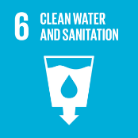

Review:
The Environment Safety Officer at Alchem International Pvt. Ltd. is responsible for overseeing the implementation and annual review of this policy. The policy will be reviewed annually to ensure its continued effectiveness, relevance, and alignment with evolving environmental, regulatory, and operational requirements. Any updates or revisions will be communicated promptly to all stakeholders, reflecting changes in operations, legislation, or emerging environmental challenges. Continuous review ensures that Alchem’s environmental practices remain proactive, compliant, and aligned with best sustainability standards.

Approved By:

Designation:

Last Review Date: 01/09/2025

Next Review Date: 01/12/2026

Employee Acknowledgement – Alchem International Pvt. Ltd. Environmental & Sustainability Policy
I acknowledge that I have received, read, and understood the Alchem International Pvt. Ltd. Environment & Sustainability Policy. I am aware of the company’s commitment to environmental stewardship, including its efforts in promoting energy efficiency, reducing greenhouse gas emissions, responsible water use, sustainable materials management, and minimizing environmental impacts across all operations.
I understand my role in supporting this policy, which includes complying with all applicable environmental laws and regulations, actively participating in Alchem International’s sustainability initiatives, and contributing to the company’s environmental goals. I agree to follow energy-saving practices, engage in proper waste management, conserve water, and responsibly use materials in my daily work.
Furthermore, I will report any environmental concerns and contribute suggestions for continuous improvement to help Alchem International achieve its sustainability targets. By signing below, I confirm my commitment to upholding the Alchem International Pvt. Ltd. Environment & Sustainability Policy and supporting the company’s mission to lead the plant-based ingredients and phytochemical industry responsibly and sustainably.

Employee Name:

Employee Signature:

Date:

